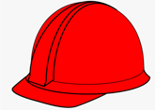OUR OCCUPATIONAL HEALTH & SAFETY POLICY

BRYCO Civil Construction P/L understand the importance of providing a fair, safe and healthy working environment. We know safe work behaviours benefit ourselves, people at work and the public. We show a serious attitude to safe work systems and practices by complying with health and safety legislation. We promote a safe work culture which aims to control risks and hazards resulting in zero injuries. We aim to review and continually improve our Occupational Health and Safety Management System.

